Online Course Registration System
SW301 - Course Project – Phase 3 - System Design
Ahmed Wael 202201415
Ahmed Sameh 202202151
Seif Eldin 202201510

Design Class Diagram

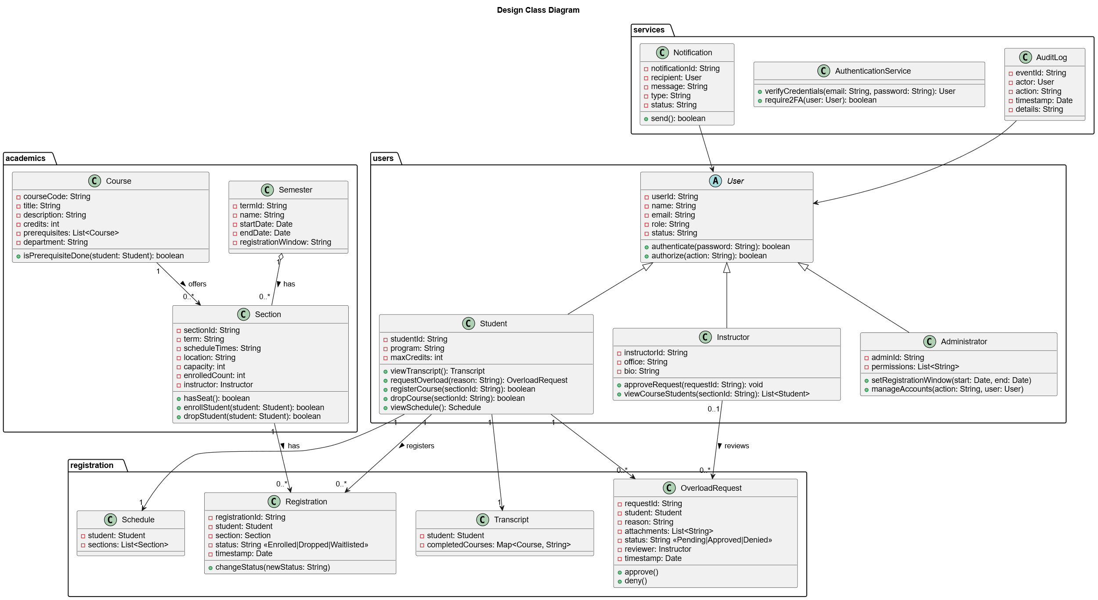

Package / Component Diagram

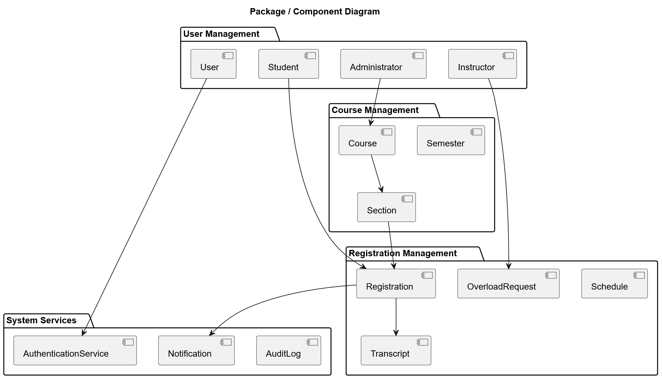

State Machine Diagram
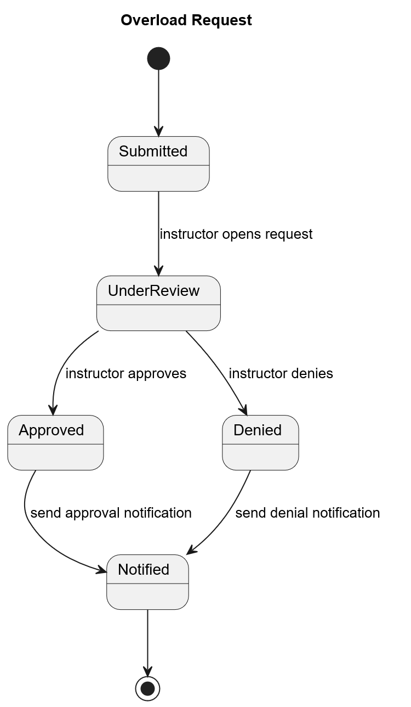

UI Mockups

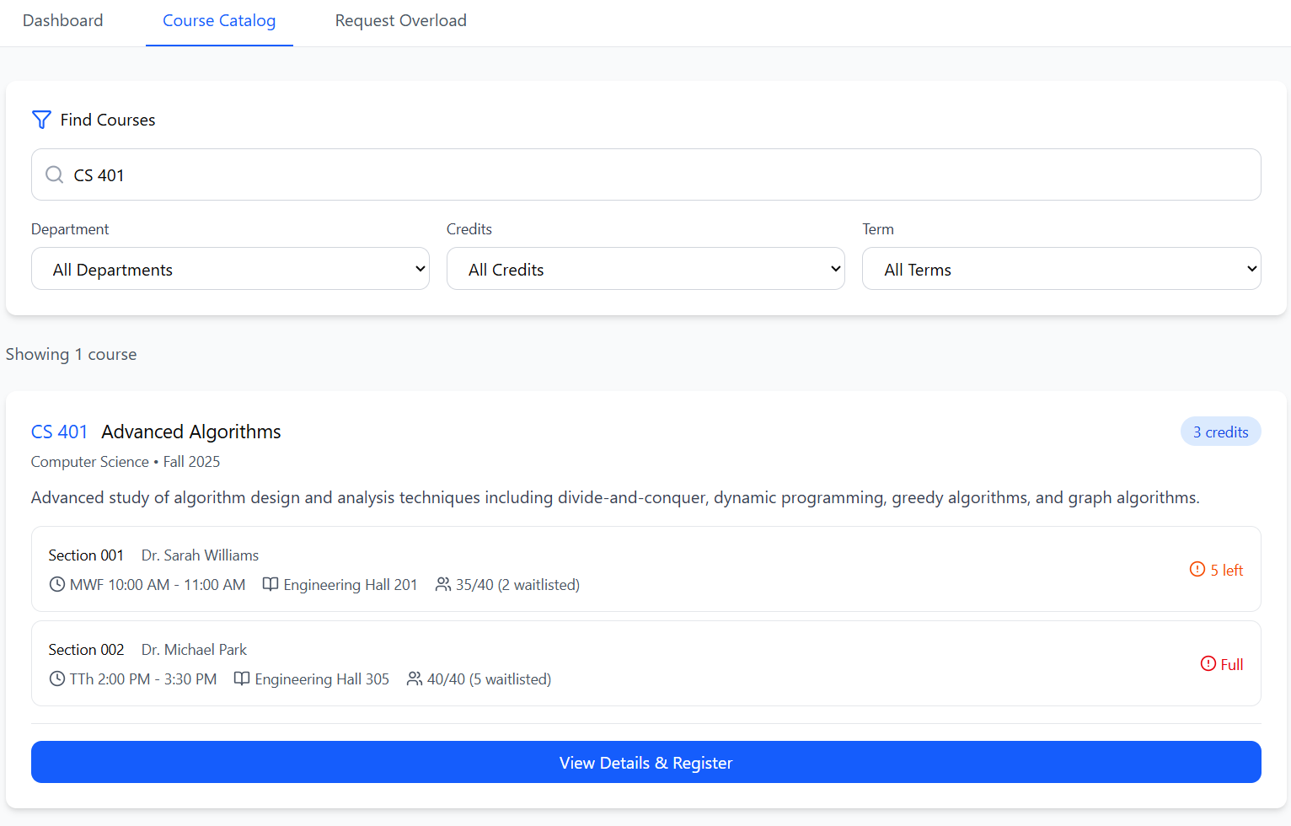
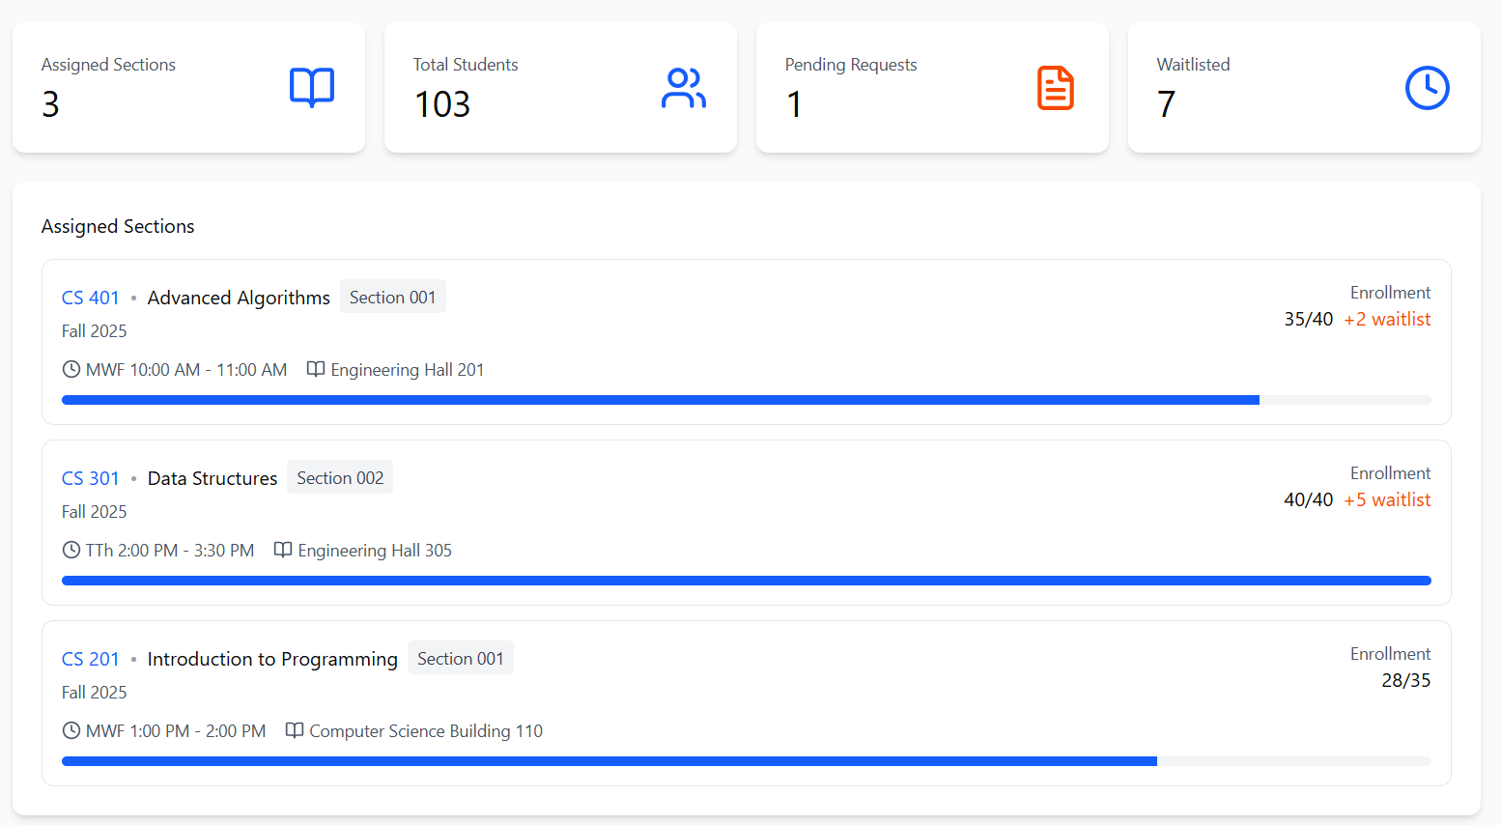


Summary
Design Approach
The system design follows object-oriented principles by refining the conceptual classes into a full design model. Each class includes specific attributes, data types, methods, and defined relationships, making the structure ready for implementation.

Key Design
1. Layered Package Structure
The system was divided into packages to separate responsibilities:
- User Management handles authentication and user roles
- Course Management maintains the academic catalog
- Registration Management processes student enrollment
- System Services manages notifications, logs, and authentication

2. Refined Class Details
Attributes now include explicit data types.
Methods are defined for the behaviors needed to support workflows.

3. Navigability and Multiplicity
Relationships now specify direction and cardinality (1..*, 0..1).
This ensures correct data traversal and prevents invalid associations.

4. State-Driven Behavior
Registration is modeled with a State Machine because it moves through states like Pending, Enrolled, Dropped, and Denied.

5. Service Abstraction
Components such as Notification, AuditLog, and AuthenticationService were isolated to support reuse across different modules.

6. UI Design Principle
UI screens are grouped by user roles (Student, Instructor, Administrator) to simplify navigation and reduce complexity for each type of user.

